CHAPTER 14 Alpha diversity
14.1 Background
Alpha diversity, or within-sample diversity, is a central concept in microbiome research. In ecological literature, several distinct but related alpha diversity indices, often referring to richness and evenness - the number of taxonomic features and how they are distributed, respectively - are commonly used (Willis 2019; Whittaker 1960). The term diversity can be used to collectively refer to all these indices.
Willis, Amy D. 2019. “Rarefaction, Alpha Diversity, and Statistics.” Frontiers in Microbiology 10. https://doi.org/10.3389/fmicb.2019.02407.
Whittaker, R. H. 1960. “Vegetation of the Siskiyou Mountains, Oregon and California.” Ecological Monographs 30 (3): 279–338. https://doi.org/https://doi.org/10.2307/1943563.
14.1.1 Applications
Alpha diversity is predominantly used to quantify complexity in the microbiome. In the general adult population, lower alpha diversity and lower bacterial load have been associated to worse overall physical and mental health (Valles-Colomer et al. 2019; Vandeputte et al. 2017). However, this principle may not generalize to other populations, most notably in early life and in patient cohorts (Ma, Li, and Gotelli 2019).
Valles-Colomer, Mireia, Gwen Falony, Youssef Darzi, Ettje F. Tigchelaar, Jun Wang, Raul Y. Tito, Carmen Schiweck, et al. 2019. “The Neuroactive Potential of the Human Gut Microbiota in Quality of Life and Depression.” Journal Article. Nature Microbiology. https://doi.org/10.1038/s41564-018-0337-x.
Vandeputte, Doris, Gunter Kathagen, Kevin D’hoe, Sara Vieira-Silva, Mireia Valles-Colomer, João Sabino, Jun Wang, et al. 2017. “Quantitative Microbiome Profiling Links Gut Community Variation to Microbial Load.” Nature 551 (7681): 507–11.
Ma, Zhanshan (Sam), Lianwei Li, and Nicholas J Gotelli. 2019. “Diversity-Disease Relationships and Shared Species Analyses for Human Microbiome-Associated Diseases.” The ISME Journal 13 (8): 1911–19. https://doi.org/10.1038/s41396-019-0395-y.
14.1.2 Approaches
The majority of alpha diversity metrics are closely related, though this is not evident from their names. Bastiaanssen et al. (2023) lay out this relationship across two factors (See table below); First, alpha diversity metrics can be defined as special cases of a unifying equation of diversity, where the Hill number determines the specific index captured. Lower Hill numbers favour richness, the number of distinct taxonomic features, whereas higher numbers favour evenness, how the taxonomic features are distributed over the sample (Hill 1973). Second, some alpha diversity metrics are weighed based on phylogeny, like Faith’s PD (1992) and PhILR (Silverman et al. 2017).
Bastiaanssen, Thomaz FS, Thomas P Quinn, and Amy Loughman. 2023. “Bugs as Features (Part 1): Concepts and Foundations for the Compositional Data Analysis of the Microbiome–Gut–Brain Axis.” Nature Mental Health 1 (12): 930–38. https://doi.org/10.1038/s44220-023-00148-3.
Hill, M. O. 1973. “Diversity and Evenness: A Unifying Notation and Its Consequences.” Ecology 54 (2): 427–32. https://doi.org/10.2307/1934352.
Faith, D. P. 1992. “Conservation Evaluation and Phylogenetic Diversity.” Biological Conservation 61 (1): 10. https://doi.org/10.1016/0006-3207(92)91201-3.
Silverman, Justin D, Alex D Washburne, Sayan Mukherjee, and Lawrence A David. 2017. “A Phylogenetic Transform Enhances Analysis of Compositional Microbiota Data.” eLife 6. https://doi.org/10.7554/eLife.21887.
 | Hill number 0 | Hill number 1 | Hill number 2
 | Dependent on presence and absence of taxonomic features, not abundance | Dependent on how evenly taxonomic features are distributed in a sample | The probability of two randomly picked taxonomic feature not being the same
Neutral Diversity  Weighs each taxon equally, no assumptions about phylogeny | Richness (Chao1) | Shannon Entropy | Simpson’s Index
Phylogenetic Diversity  Indices are scaled based on taxonomic closeness with a phylogenetic tree | Faith’s Phylogenetic Diversity | Phylogenetic Entropy | Rao’s Quadratic Diversity
The equation for general diversity can be defined as follows: ${{}^qD = (_{i=1}^{{R}p}q_i})^{}$,
with q = Hill number, R = number of features, p = relative feature abundance.
Cassol et al. (2025) offer practical guidelines for selecting alpha diversity indices. They classify alpha diversity into four main categories and recommend calculating at least one metric from each category, if possible, to sufficiently capture within-sample diversity. Since indices within the same category tend to be correlated, they suggest using the simplest available metric. Below are the default choices for each category.
- Richness: The number of observed unique features
- Dominance: Berger-Parker
- Information: Shannon
- Phylogenetics: Faith
Note: Richness estimators and denoising
Several estimators have been developed to address the confounding effect of limited sampling size on observed richness, most notably ACE (A and SM 1992) and Chao1 (A 1984). Notably, these approaches may yield misleading results for modern 16S data, which commonly features denoising and removal of singletons (Deng, Umbach, and Neufeld 2024).
Deng, Yongcui, Alexander K Umbach, and Josh D Neufeld. 2024. “Nonparametric Richness Estimators Chao1 and ACE Must Not Be Used with Amplicon Sequence Variant Data.” The ISME Journal 18 (1): wrae106. https://doi.org/10.1093/ismejo/wrae106.
A, Chao. 1984. “Non-Parametric Estimation of the Number of Classes in a Population.” Scandinavian Journal of Statistics 11 (4): 265–70. https://www.jstor.org/stable/4615964.
A, Chao, and Lee SM. 1992. “Estimating the Number of Classes via Sample Coverage.” Journal of the American Statistical Association 87 (417): 210–17. https://doi.org/https://doi.org/10.1080/01621459.1992.10475194.
14.2 Examples
14.2.1 Calculate alpha diversity measures
Alpha diversity can be estimated with the addAlpha() function, which includes built-in methods for calculating some indices, while others are computed via integration with the vegan (Oksanen et al. 2020) package. The method calculates the given indices, and add them to the colData slot of the SummarizedExperiment object with the given name.
Oksanen, Jari, F. Guillaume Blanchet, Michael Friendly, Roeland Kindt, Pierre Legendre, Dan McGlinn, Peter R. Minchin, et al. 2020. Vegan: Community Ecology Package. https://CRAN.R-project.org/package=vegan.
# First, let's load some example data.
library(mia)
data("GlobalPatterns")
tse <- GlobalPatterns

# The 'index' parameter allows computing multiple diversity indices
# simultaneously. Without specification, four standard indices are calculated:
# dbp_dominance, faith_diversity, observed_richness, and shannon_diversity.
tse <- addAlpha(
tse,
assay.type = "counts",
detection = 10
)

# Check some of the first values in colData
tse$observed_richness |> head()
## [1] 3144 3791 2319 761 671 1004
tse$shannon_diversity |> head()
## [1] 6.577 6.777 6.498 3.828 3.288 4.289
Certain indices have additional options, here observed has detection parameter that control the detection threshold. Species over this threshold is considered as detected. See full list of options from from help(addAlpha).
Note: Phylogenetic distances require a tree
Because tse is a TreeSummarizedExperiment object, its phylogenetic tree is used by default. However, the optional argument tree must be provided if tse does not contain a rowTree.
14.2.2 Visualize alpha diversity measures
As alpha diversity metrics typically summarize high-dimensional samples into singular values, many visualization approaches are available. Once calculated, these metrics can be analyzed directly from the colData, for example, by plotting them using plotColData() from the scater package (McCarthy et al. 2020). Here, we use the observed species as a measure of richness. Let’s visualize the results against selected colData variables (sample type and final barcode).
McCarthy, Davis, Kieran Campbell, Aaron Lun, and Quin Wills. 2020. Scater: Single-Cell Analysis Toolkit for Gene Expression Data in r. http://bioconductor.org/packages/scater/.
library(scater)
plotColData(
tse,
"observed_richness",
"SampleType",
colour_by = "Final_Barcode") +
theme(axis.text.x = element_text(angle = 45, hjust = 1)) +
labs(x = "Sample types", y = expression(Richness[observed_richness]))
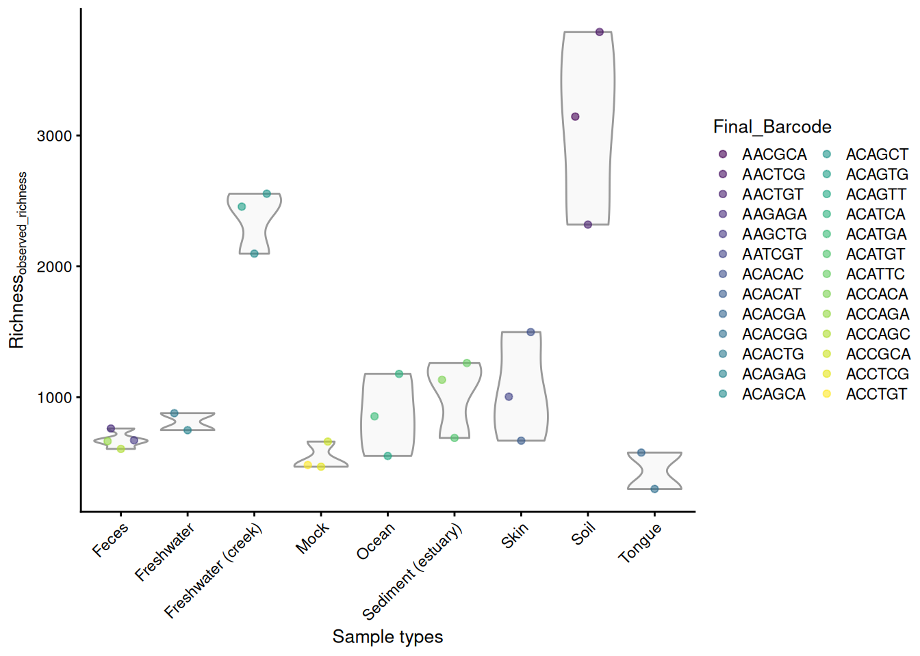
Observerd richness plotted grouped by sample type with colour-labeled barcode.
14.2.2.1 Alpha diversity measure comparisons
We can compare alpha diversities for example by calculating correlation between them. Below, a visual comparison between shannon and faith indices is shown with a scatter plot.
plotColData(tse, x = "shannon_diversity", y = "faith_diversity") +
labs(x="Shannon index", y="Faith (phylogenetic) index") +
geom_smooth(method = "lm")
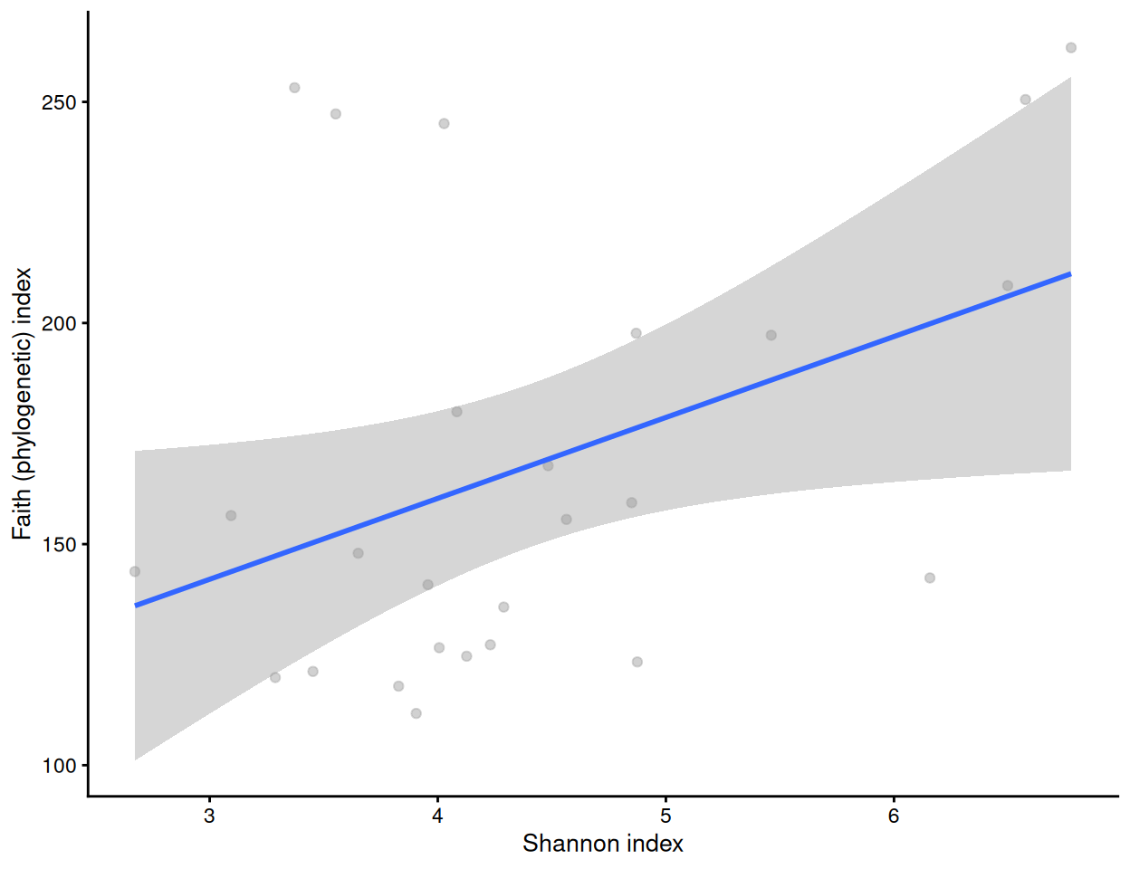
cor.test(tse[["shannon_diversity"]], tse[["faith_diversity"]])
##
## Pearson's product-moment correlation
##
## data: tse[["shannon_diversity"]] and tse[["faith_diversity"]]
## t = 2.2, df = 24, p-value = 0.04
## alternative hypothesis: true correlation is not equal to 0
## 95 percent confidence interval:
## 0.02719 0.68822
## sample estimates:
## cor
## 0.4102
Let us visualize results from multiple alpha diversity measures against a given sample grouping available in colData (here, sample type). These have been readily stored in the colData slot, and they are thus directly available for plotting.
library(patchwork)

# Create the plots
indices <- c(
"observed_richness", "dbp_dominance", "shannon_diversity",
"faith_diversity"
)
plots <- lapply(
indices,
plotColData,
object = tse,
x = "SampleType",
colour_by = "SampleType"
)

# Fine-tune visual appearance
plots <- lapply(
plots, "+",
theme(axis.text.x = element_blank(),
axis.title.x = element_blank(),
axis.ticks.x = element_blank()))

# Plot the figures
wrap_plots(plots, ncol = 1) +
plot_layout(guides = "collect")
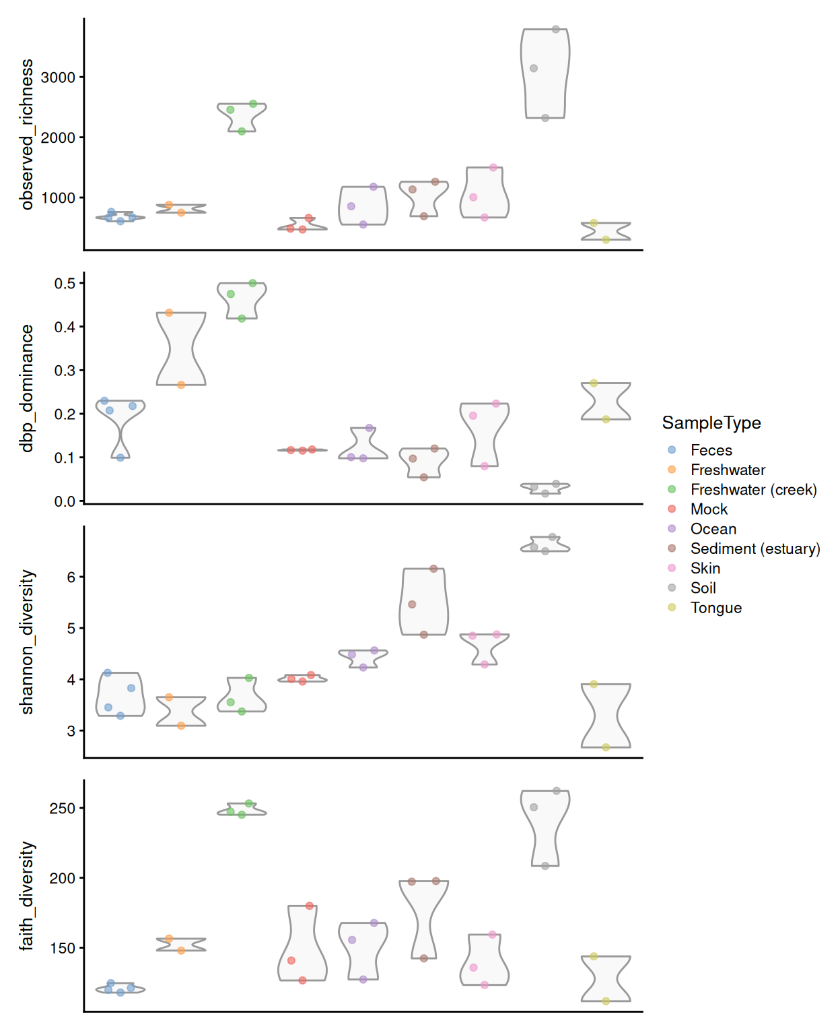
All these different metrics provide information from different aspects of alpha diversity, notably on richness, dominance, information, and phylogenetic diversity described in (Cassol, Ibañez, and Bustamante 2025). It is recommended to interpret these aspects separately and together.
Cassol, Ignacio, Mauro Ibañez, and Juan Pablo Bustamante. 2025. “Key Features and Guidelines for the Application of Microbial Alpha Diversity Metrics.” Scientific Reports 15 (1). https://doi.org/10.1038/s41598-024-77864-y.
From our example, we can observe that soil and freshwater (creek) have the highest number of different taxonomic features present while tongue microbiome has the lowest richness, suggesting greater biodiversity in soil and freshwater samples.
Based on the dominance values, species abundances in the soil samples appeared to be relatively evenly distributed. In contrast, the freshwater microbiome — particularly in the freshwater creek samples — was dominated by a single species, despite showing high observed richness.
These observations are supported by the Shannon index, which accounts for both richness and dominance. Soil samples showed the highest Shannon diversity, reflecting their high number of observed species and relatively even species distribution.
Soil and freshwater creek environments host a wide range of phylogenetically diverse organisms, indicating that the observed taxonomic features are not closely related but rather distinct from one another in terms of their evolutionary history.
In summary, soil samples exhibit the highest biodiversity, while human-derived samples show less variation in terms of species composition and evolutionary diversity.
14.2.3 Statistical analysis of alpha diversity measures
We can then analyze the statistical significance. We use the non-parametric Wilcoxon or Mann-Whitney test, as it is more flexible than the commonly used Student’s t-Test, since it does not assume normality.
pairwise.wilcox.test(
tse[["observed_richness"]], tse[["SampleType"]], p.adjust.method = "fdr")
##
## Pairwise comparisons using Wilcoxon rank sum exact test
##
## data: tse[["observed_richness"]] and tse[["SampleType"]]
##
## Feces Freshwater Freshwater (creek) Mock Ocean
## Freshwater 0.4 - - - -
## Freshwater (creek) 0.3 0.3 - - -
## Mock 0.3 0.3 0.3 - -
## Ocean 0.8 1.0 0.3 0.3 -
## Sediment (estuary) 0.3 0.8 0.3 0.3 0.8
## Skin 0.3 0.8 0.3 0.3 0.8
## Soil 0.3 0.3 0.5 0.3 0.3
## Tongue 0.3 0.5 0.3 0.8 0.5
## Sediment (estuary) Skin Soil
## Freshwater - - -
## Freshwater (creek) - - -
## Mock - - -
## Ocean - - -
## Sediment (estuary) - - -
## Skin 1.0 - -
## Soil 0.3 0.3 -
## Tongue 0.3 0.3 0.3
##
## P value adjustment method: fdr
14.2.3.1 Visualizing significance in group-wise comparisons
Next, let’s compare the Shannon index between sample groups and visualize the statistical significance. Using the stat_compare_means function from the ggpubr package, we can add visually appealing p-values to our plots.
To add adjusted p-values, we have to first calculate them.
library(ggpubr)
library(tidyverse)

index <- "shannon_diversity"
group_var <- "SampleType"

# Subsets the data. Takes only those samples that are from feces, skin, or
# tongue.
tse_sub <- tse[ , tse[[group_var]] %in% c("Feces", "Skin", "Tongue") ]

# Changes old levels with new levels
tse_sub$SampleType <- factor(tse_sub$SampleType)

# Calculate p values
pvals <- pairwise.wilcox.test(
tse_sub[[index]], tse_sub[[group_var]], p.adjust.method = "fdr")
# Put them to data.frame format
pvals <- pvals[["p.value"]] |>
as.data.frame()
varname <- "group1"
pvals[[varname]] <- rownames(pvals)
# To long format
pvals <- reshape(
pvals,
direction = "long",
varying = colnames(pvals)[ !colnames(pvals) %in% varname ],
times = colnames(pvals)[ !colnames(pvals) %in% varname ],
v.names = "p",
timevar = "group2",
idvar = "group1"
) |>
na.omit()
# Add y-axis position
pvals[["y.position"]] <- apply(pvals, 1, function(x){
temp1 <- tse[[index]][ tse[[group_var]] == x[["group1"]] ]
temp2 <- tse[[index]][ tse[[group_var]] == x[["group2"]] ]
temp <- max( c(temp1, temp2) )
return(temp)
})
pvals[["y.position"]] <- max(pvals[["y.position"]]) +
order(pvals[["y.position"]]) * 0.2
# Round values
pvals[["p"]] <- round(pvals[["p"]], 3)

# Create a boxplot
p <- plotColData(
tse_sub, x = group_var, y = index,
show_boxplot = TRUE, show_violin = FALSE) +
theme(text = element_text(size = 10)) +
stat_pvalue_manual(pvals)
p
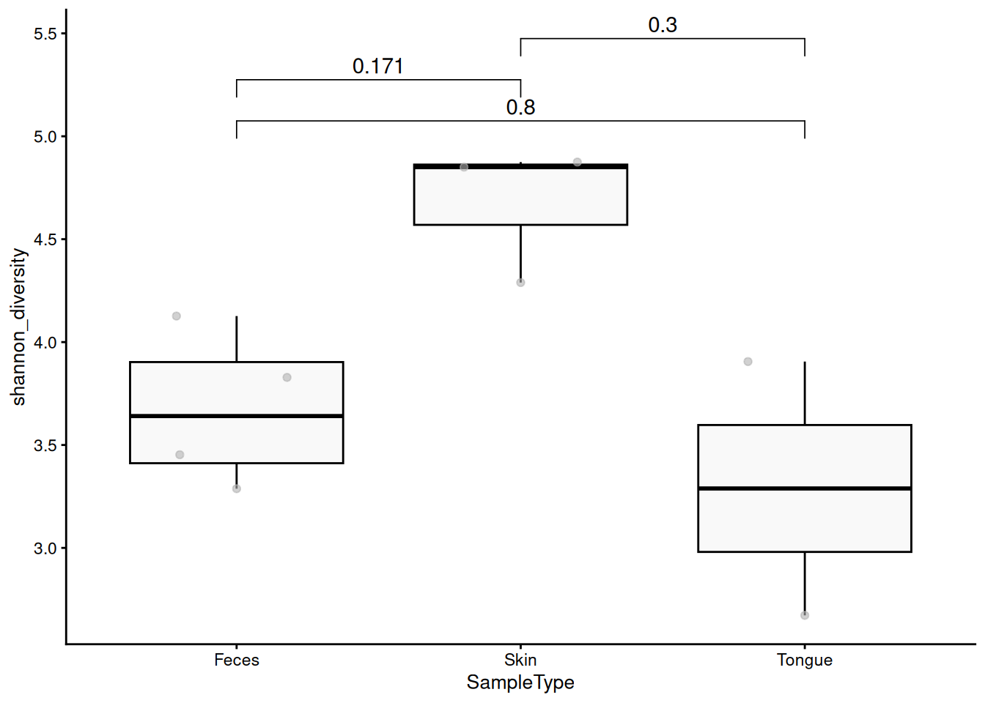
14.3 Further reading
Article on ggpubr package provides further examples for estimating and highlighting significances.
Exercises
Goal: The goal of these exercises is to learn to calculate alpha diversities and to compare them between sample groups.
Exercise 1: Alpha diversity
- Load any of the example datasets mentioned in Section 4.2.
- Calculate Shannon diversity index, and add the results to colData().
- Observe colData, especially its column names.
- Summarize the distribution of Shannon diversity with a histogram. Is there variance in alpha diversities?
- Calculate Shannon diversity index with rarefaction and store it to colData as column "shannon_rarefaction".
- Calculate correlation between Shannon indices, with and without rarefaction. Do they correlate? If the correlation is relatively weak, what might explain this? If they correlate very strongly, why is that? What rarefaction does and for what it can be used?
- Visualize the correlation.
- Calculate all available indices.
- Visualize single diversity index in respect to some sample grouping that you can find from colData. Can you see difference between groups?
- Calculate statistical significance of difference in selected alpha diversity index between the sample groups. Do the results confirm your observation in step 9?
Useful functions:
utils::data(), mia::addAlpha(), miaViz::plotHistogram(), mia::getCrossAssociation(), scater::plotColData(), geom_smooth(method = "lm"), stats::wilcox.test(), stats::pairwise.wilcox.test(), stats::kruskal.test()

